**Ideapoke Technologies Pvt. Ltd.**



**Software Installation Document**

Version: V1.0.0

Created by Niharika

Created on: 05-10-2021

**Document Control**

* **Revision history**

|  |  |  |  |  |
| --- | --- | --- | --- | --- |
| **Date** | **Version** | **Description** | **Author** | **Email** |
| 05-10-2021 | V1.0.1 | Initial Document | Niharika | Niharika.ta@ideapoke.com |
|  |  |  |  |  |
|  |  |  |  |  |

* **Document reviews**

|  |  |  |  |  |
| --- | --- | --- | --- | --- |
| **Name** | **Email** | **Role** | **Date** | **Comments** |
|  |  |  |  |  |
|  |  |  |  |  |

* **Document approval**

|  |  |  |  |  |
| --- | --- | --- | --- | --- |
| **Date** | **Version** | **Description** | **Approver** | **Email** |
|  |  |  |  |  |
|  |  |  |  |  |

1. **INTRODUCTION**

Purpose of this document to know the required software details to install for web development.

## **1.1. Java 1.8**

How to install Java 1.8?

Following are the steps on how to install Java in Windows 10 for JDK8 download for Windows 64 bit and installation

#### **Step 1)** Go to [link](https://www.oracle.com/java/technologies/javase/javase8-archive-downloads.html). Check for **Java SE Development Kit 8u181**

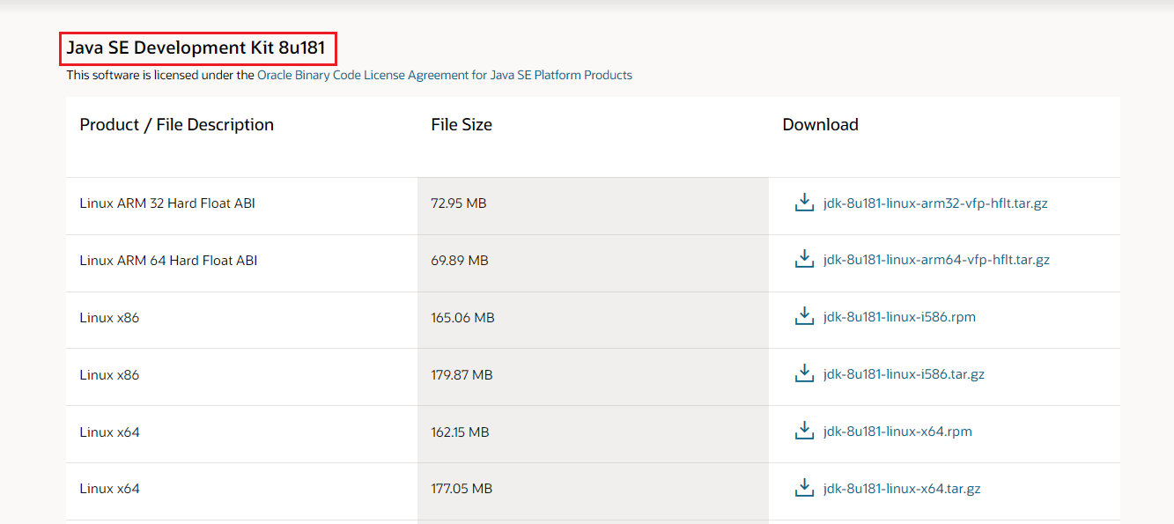

**Step 2)** Next, Click on Download Java 8 JDK for version 64 bit.

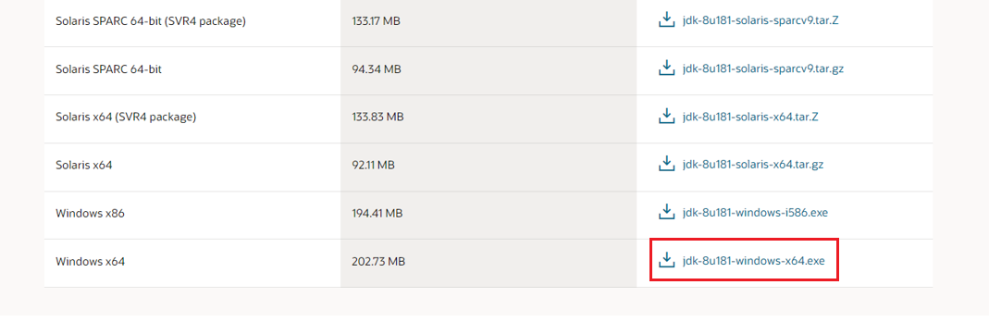

**Step 3)** When you click on the Installation link the popup will be open. Click on I reviewed and accept the Oracle Technology Network License Agreement for Oracle Java SE development kit and you will be redirected to the login page. If you don’t have an oracle account you can easily sign up by adding basics details of yours.

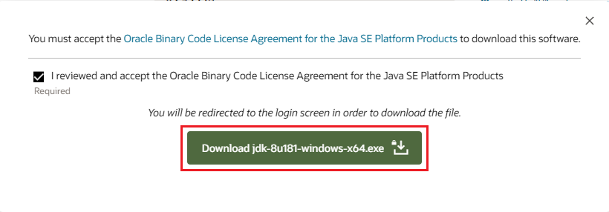

**NOTE:** You will be required to create an Oracle Account to start Java 8 download of the file.

**Step 4)** Once the Java JDK 8 download is complete, run the exe for install JDK. Click Next

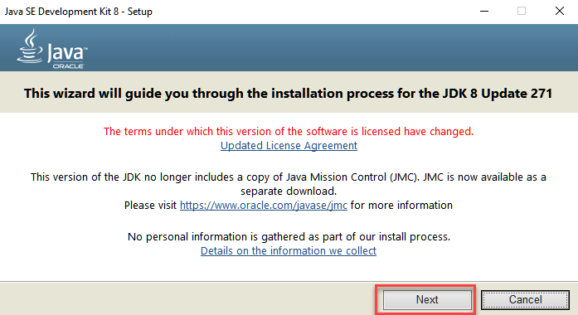

**Step 5)** Select the PATH to install Java in Windows… You can leave it Default. Click next.

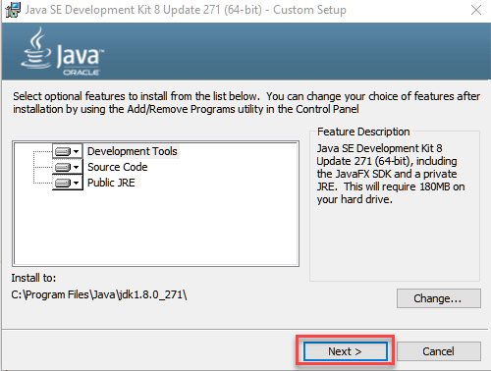

**NOTE:** Follow the onscreen instructions in succeeding steps to install Java 8 on Windows 10.

**Step 6)** Once you install Java in windows, click Close

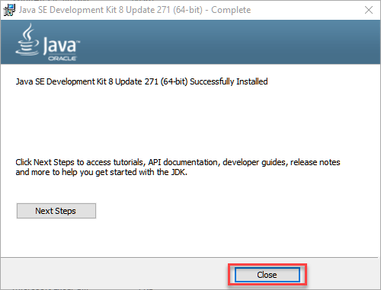

## **How to set Environment Variables in Java: Path and Classpath**

The PATH variable gives the location of executables like javac, java etc. It is possible to run a program without specifying the PATH but you will need to give full path of executable like **C:\Program Files\Java\jdk1.8.0_271\bin\javac A.java** instead of simple **javac A.java**

The CLASSPATH variable gives location of the Library Files.

Let’s look into the steps to set the PATH and CLASSPATH

**Step 1)** Right Click on the My Computer and Select the properties

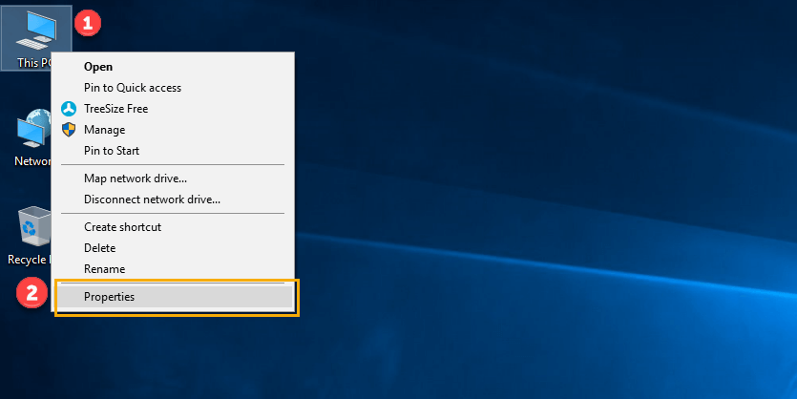

**Step 2)** Click on advanced system settings

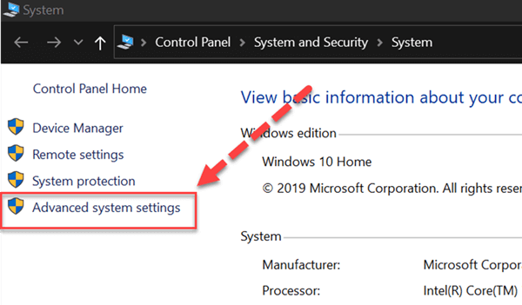

**Step 3)** Click on Environment Variables to set Java runtime environment

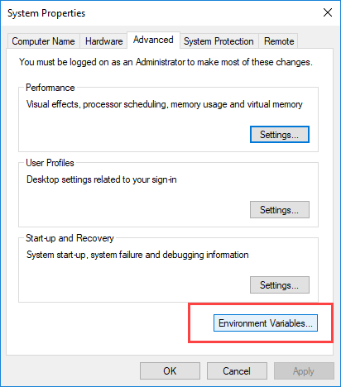

**Step 4)** Click on new Button of User variables

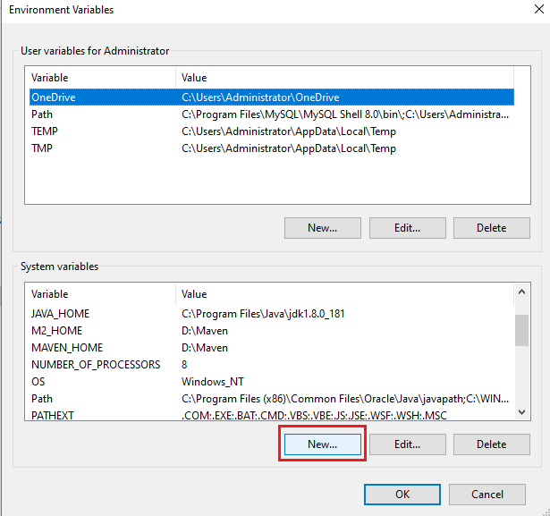

**Step 5)** Copy the path of bin folder which is installed in JDK folder.

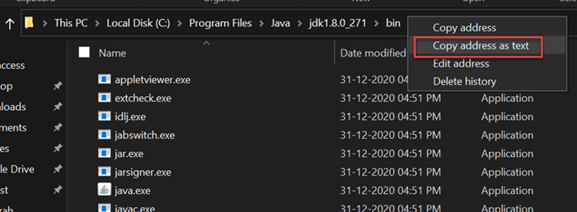

**Step 6)** Paste Path of bin folder in Variable value. Click on OK Button.

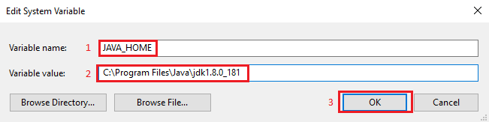

**Step 7)** Go to existing path in system variables and Click on **Edit** Button.

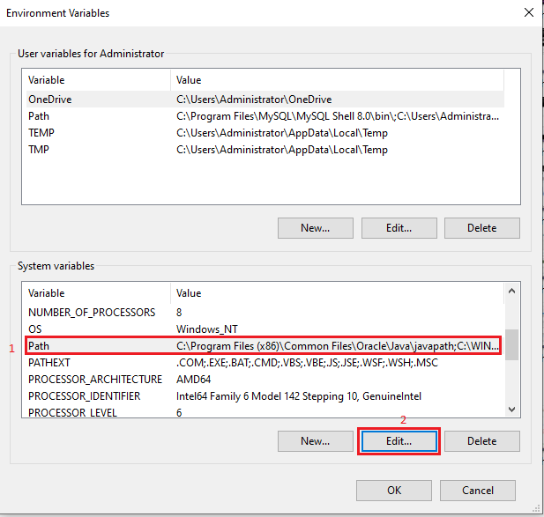

**Step 8)** Now click on new, add the bin path **C:\Program Files\Java\jdk1.8.0_181\bin** and Click on **OK** Button.

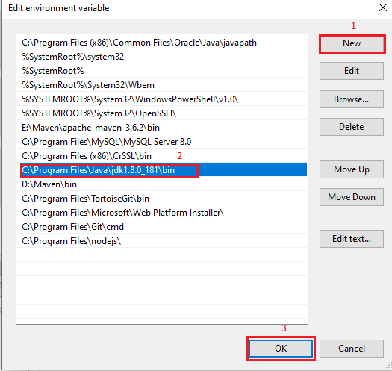

**Step 9)** Click on OK button

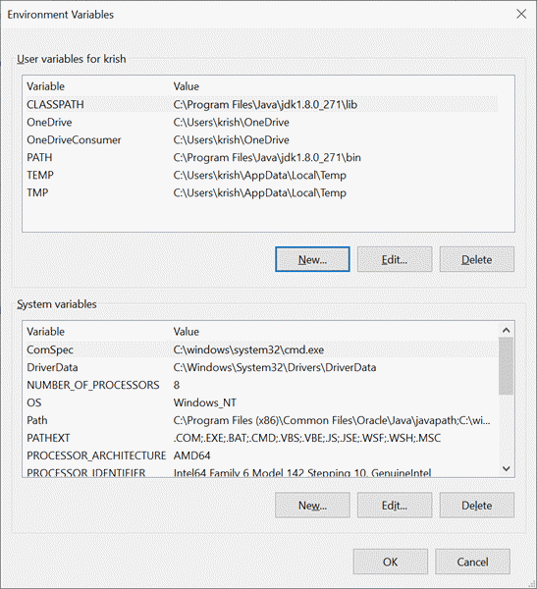

**Step 10)** Go to command prompt and type javac commands.

If you see a screen like below, Java is installed.

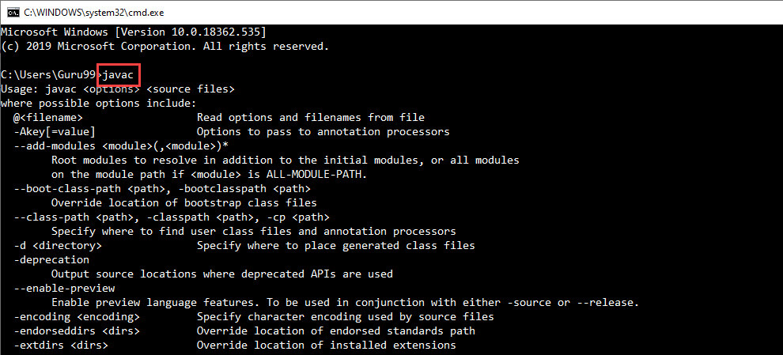

## **1.2. Notepad++**

Download link: <https://notepad-plus-plus.org/downloads/v8.1.5/>

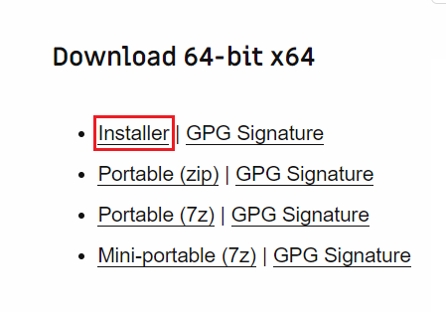

## **1.3. Textpad**

Download link: <https://www.textpad.com/download>

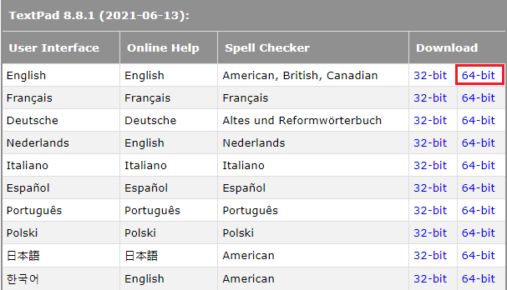

## **1.4. 7Zip**

Download link: <https://www.7-zip.org/download.html>

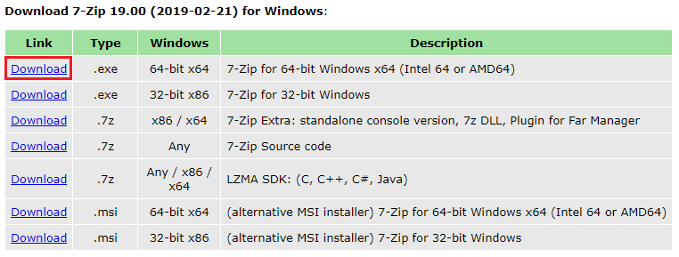

## **1.5. Eclipse**

Following is a step-by-step guide to download and install Eclipse IDE:

**Step 1)** Installing Eclipse

Open your browser and type <https://www.eclipse.org/>

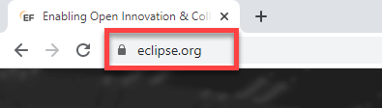

**Step 2)** Click on “Download” button.

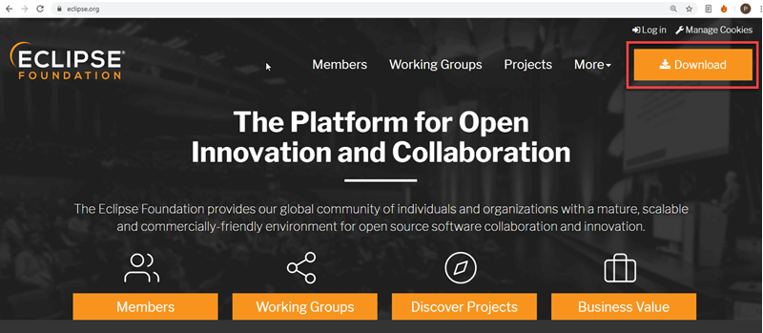

**Step 3)** Click on “Download 64 bit” button.

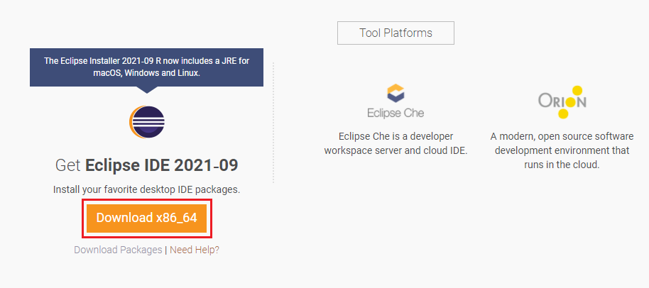

**Step 4)** Click on “Download” button.

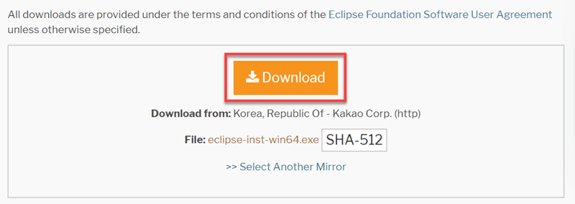

**Step 5)** Install Eclipse.

* 1. Click on “downloads” in Windows file explorer.
  2. Click on “eclipse-inst-win64.exe” file.

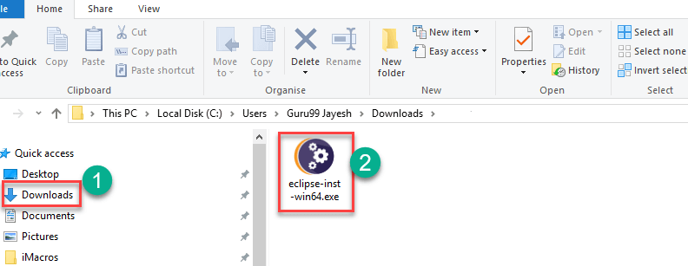

**Step 6)** Click on Run button.

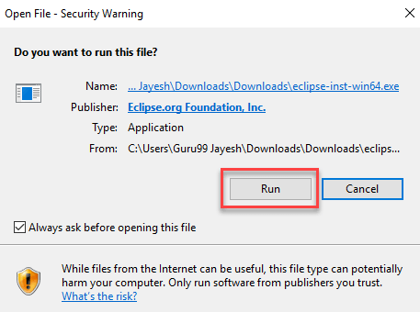

**Step 7)** Click on “Eclipse IDE for Java Developers”

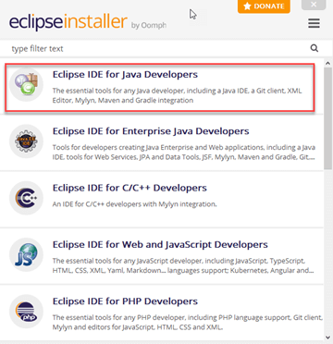

**Step 8)** Click on “INSTALL” button

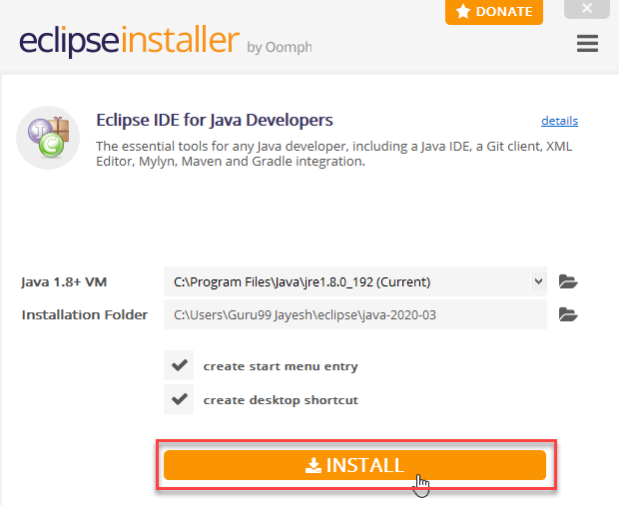

**Step 9)** Click on “LAUNCH” button.

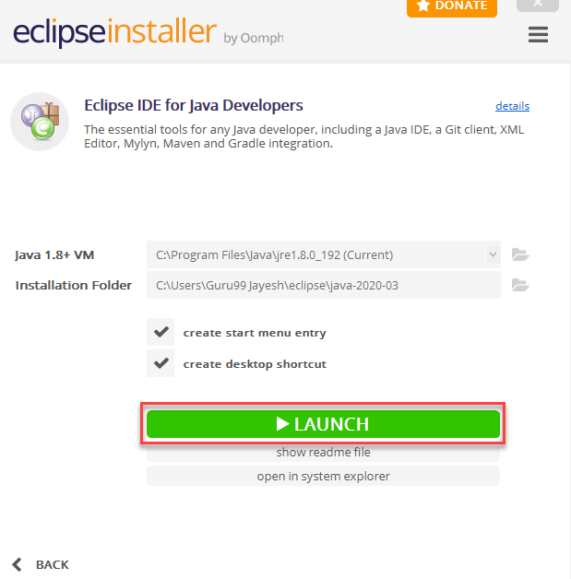

**Step 10)** Browse a java directory, Click on “Launch” button.

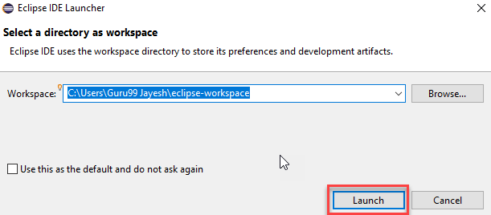

## **1.6. MySQL 8.0.20**

Download link: <https://downloads.mysql.com/archives/installer/>

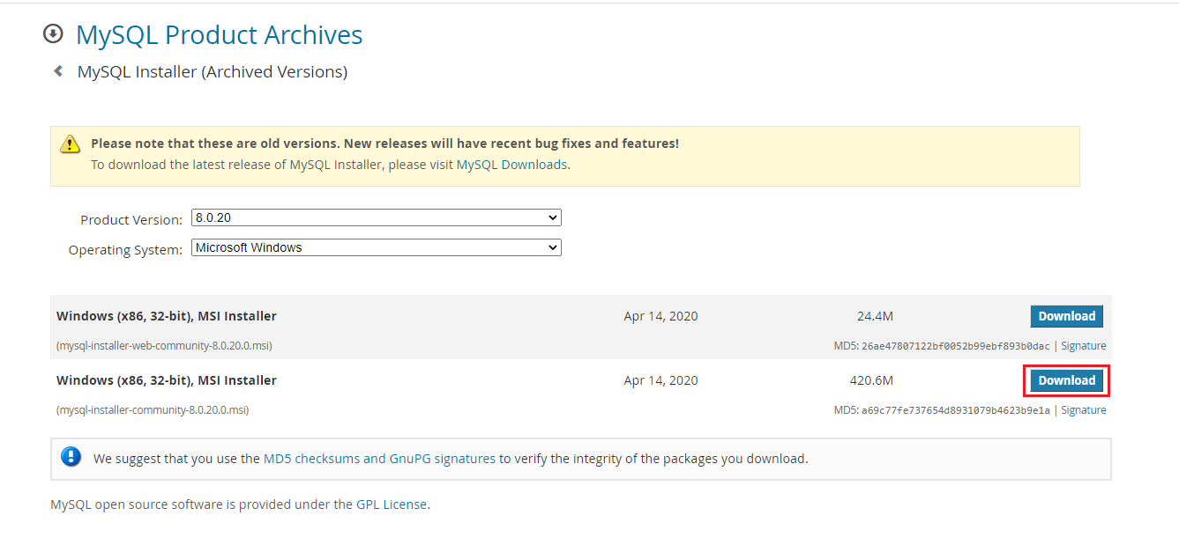

## **1.7. MySQL Yog**

Download link: <https://webyog.com/product/sqlyog/>

## **1.8. Tomcat 8.5**

Download link: <https://archive.apache.org/dist/tomcat/tomcat-8/v8.5.0/bin/>

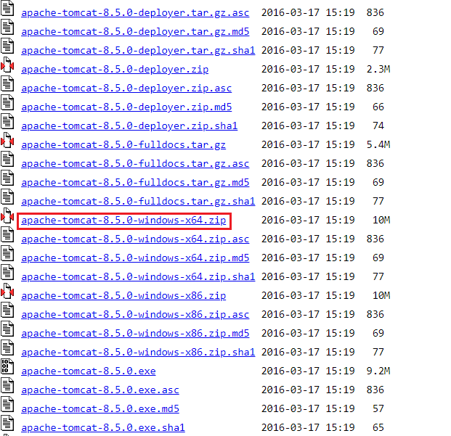

## **1.9. Beyond compare**

Download link: <https://www.scootersoftware.com/download.php>

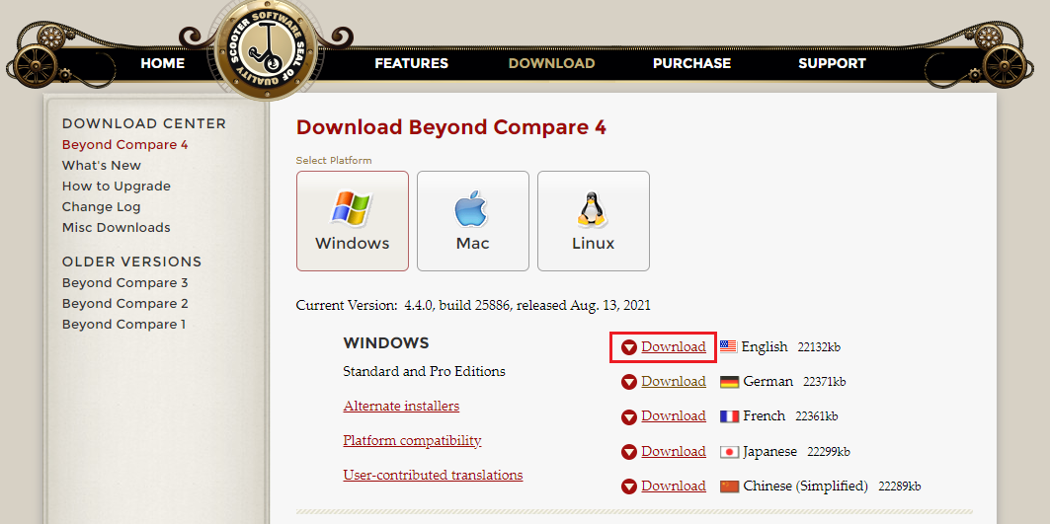

## **2.0. Git**

Download git for windows <https://git-scm.com/download/win>

<https://ideapoketech.sharepoint.com/:w:/s/DevelopmentTeam/ETZQ6Uoy_alCnjv6Rav1VKEBtrYwonLtcFsL00RBYVqe6w?e=hQAuXj>

## **2.1. Tortoise GIT**

Download link: <https://tortoisegit.org/download/>

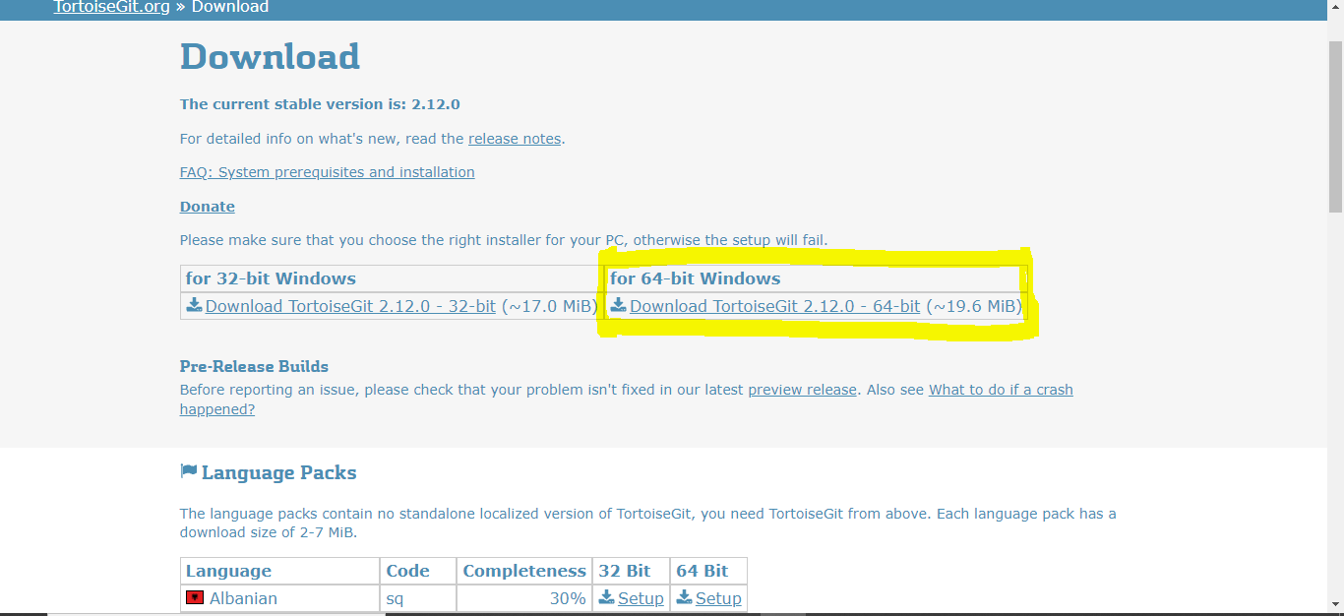

## **2.2. Maven**

<https://ideapoketech.sharepoint.com/:w:/s/De\velopmentTeam/EVOGroAtFqBPhmmtchJmXIsBl9ew45YH7zicI-qp6IKgVA?e=g6oNge>